The Victorian era and Industrial Revolution
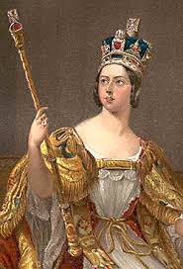
- Who were the Victorians?
The Victorian age in British history is named after Queen Victoria, who was Britain's queen from 1837 until 1901.
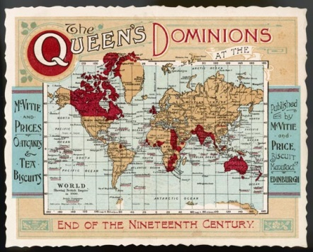
What was life like for Victorian children? There were big differences in homes, schools, toys and entertainments. No TV, no computers, no central heating, no cars (until the last few years of Victoria's reign). No air travel - unless you went up in a balloon! Many children went to work, not to school. Welcome to the Victorian world. It's time to find out how children lived more than a hundred years ago.
- The British Empire
Britain ruled the British Empire. Victoria was Empress of India as well as Queen of Britain, Canada (the biggest country in the Empire) and small countries such as Jamaica. Trade with the Empire helped make Britain rich. Some British children emigrated with their families to new homes in Australia, New Zealand, South Africa and Canada. Children were taught about the Empire in school.
In Victorian classrooms, children could easily find the countries of the Empire on a map because they were coloured pink or red.
Countries of the commonwealth today.
Africa Botswana Cameroon Ghana Kenya Lesotho Malawi Mauritius Mozambique Namibia Nigeria Rwanda Seychelles Sierra Leone South Africa Swaziland Uganda United Republic of Tanzania Zambia
Asia Bangladesh Brunei Darussalam India Malaysia Maldives Pakistan Singapore Sri Lanka
Caribbean and Americas Antigua and Barbuda Bahamas, The Barbados Belize Canada Dominica Grenada Guyana Jamaica Saint Lucia St Kitts and Nevis St Vincent and The Grenadines Trinidad and Tobago
Europe Cyprus Malta United Kingdom
Pacific Australia Fiji Kiribati Nauru New Zealand Papua New Guinea Samoa Solomon Islands Tonga Tuvalu Vanuatu
The Industrial Revolution
The Industrial Revolution changed Britain from a land of small towns, villages and farms into a land of cities, large towns and factories. The population grew from 16 million in 1801 to over 41 million by 1901. Cities grew fast, as people moved from the countryside to work in factories.
Men, women and children worked in factories, and in coal mines. Factory and mine owners became rich, but most factory and mine workers were poor. They were paid low wages, and lived in unhealthy, overcrowded slums.
- Who went to school?
At the start of the 19th century very few children went to school. Most poor children worked. If they went to school, their families lost the money they earned.
There were some good schools for boys, for example, grammar schools and public schools. Only richer families could afford to pay the school fees, though some schools gave free places to poor boys. Poor girls did not go to school when the Victorian age began meaning they had little education. Girls from wealthy families would usually be taught at home by a governess. Sometimes, wealthy girls may have attended boarding schools too.
- Dame schools
'Dame' schools were usually run by one woman. The 'dame' often did her best, but she was a child-minder not a trained teacher. Often quite poor herself, she took as many children as she could cram into her house. Poor parents working hard to earn a living paid her a few pennies a week to look after their children, and perhaps teach them the alphabet or how to sew. Most of the time, the children amused themselves and did not learn very much.
- Ragged schools and Sunday schools.
Sunday schools were run by churches, to teach children about the Christian faith. Journalist Robert Raikes started the first Sunday School for poor children in Gloucester in 1780.
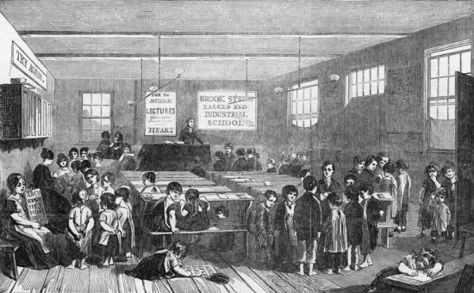
Ragged Schools were schools for poor children. One of the first was started in Portsmouth by a shoe-mender named John Pounds. Older children helped to teach younger ones. Ragged Schools were often in one room of a house, or in an old barn. From 1833 factory owners were supposed to provide at least 2 hours education every day for child-workers, but not many children actually got lessons.
- School for all
Reformers campaigned for new laws to improve working conditions for children and give children the opportunity for schooling. In 1870 Parliament said there had to be a school in every town and village. 'School Boards' of local people built and ran the new schools. Families paid a few pennies a week to send their children, though not all children went to school. In the 1860s a farmer might pay 6 pence (6d) a week for each child. A labourer (who earned less) only paid 2d per child.
By 1880, the law said that all children aged 5 to 10 must go to primary school, so every child would receive at least a basic education.
- Outings and Treats
At weekends, families might go to the park, and listen to a band. Crowds would gather round the bandstand to enjoy the music. Zoos were popular too. Children rode on elephants and camels, and watched the lions being fed. At Easter, there was Maypole dancing and a May Queen was chosen, and paraded through the streets. Poor children looked forward to treats such as day trips and picnics. These were often run by youth organizations such as the Band of Hope and the Boys' Brigade.
- Going to the Seaside
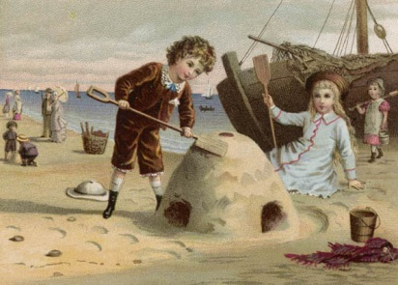
Railways changed people's lives. Families went to the seaside for the day by train. People who could afford it took a week's summer holiday. Seaside towns such as Blackpool and Margate became popular resorts. Trippers and holidaymakers enjoyed things we still enjoy at the seaside today: ice cream, fish and chips, riding on donkeys, paddling and making sandcastles on the beach. In old photos you'll notice most people are wearing ordinary clothes, with trousers and skirts rolled up to keep dry.
- Travelling shows
Funfairs and circuses travelled around the country. Funfairs had roundabouts (worked by steam engines), slides and swings, coconut shies, shooting galleries and sideshows with strongmen, fire-eaters, jugglers and fortune-tellers. Circuses put on shows in big tents, and often paraded into the town on arrival with the clowns, elephants, horses and camels. Children laughed at Punch and Judy, a one-man travelling puppet show.
- Theatre and Pantomime
The Victorians loved theatre, and most towns had at least one theatre or music hall. At Christmas, lucky children were taken to the pantomime. This was often a lavish show with exciting special effects (lights, smoke, loud bangs, live animals). Poor children who could not afford a theatre seat might get a job in the pantomime as 'juvenile dancers' or 'crowds'. Children paid a penny to get into the cheap music halls, and came out whistling the latest popular song.
- Rich and poor families
In Victorian times, many families had 10 or more children. Sadly, many children died as babies, or from diseases such as smallpox and diphtheria. Child-death struck rich and poor families.
In a Victorian town, it was easy to tell who was rich and who was poor. Children from richer homes were well fed, wore warm clothes and had shoes on their feet. They did not work, but went to school or had lessons at home.
Poor children looked thin and hungry, wore ragged clothes, and some had no shoes. Poor children had to work. They were lucky if they went to school.
- Why did children go to work?
Many Victorian children were poor and worked to help their families. Few people thought this strange or cruel. Families got no money unless they worked, and most people thought work was good for children. The Industrial Revolution created new jobs, in factories and mines. Many of these jobs were at first done by children, because children were cheap - a child was paid less than adults (just a few pennies for a week's work).
- When did children start work?
Many children started work at the age of 5, the same age as children start school today. They went to work as soon as they were big enough. Even a tiny child could feed chickens. Older brothers and sisters took small children to work, perhaps to a factory at the end of the street. Other children worked at home, doing jobs such as washing, sewing, sticking labels on bottles or making brushes.
- What jobs did children do?
Children worked on farms, in homes as servants, and in factories. Children often did jobs that required small size and nimble fingers. But they also pushed heavy coal trucks along tunnels in coal mines. Boys went to sea, as boy-sailors, and girls went 'into service' as housemaids. Children worked on city streets, selling things such as flowers, matches and ribbons. Crossing boys swept the roads clean of horse-dung and rubbish left by the horses that pulled carts and carriages.
- Why was coal so important?
Most of the energy we use today comes in the form of electricity or oil. In Victorian times, energy came from water-power (waterwheels), from horses and above all from burning coal. Coal was as important to Victorians as oil is to us today. Steam engines burned coal. Steam engines drove factory machines, locomotives pulling trains and steamships. All this coal had to be dug from coal mines. Britain had a lot of coal, deep in rocks beneath the ground. .
- What were coal mines like?
Most coal was dug from deep mines. A long vertical shaft was dug down from the surface. Leading off from it were side tunnels. Miners rode in a lift, worked by a steam engine. In the tunnels, they hacked at the coal with picks and shovels. Coal mines were dark, dirty and dangerous. The only light came from candles and oil lamps. Gas in the mine could choke miners, or explode. Tunnels could flood or collapse. Accidents killed many miners.
- How were coal mines run?
Coal mines were owned by the person on whose land they were dug. The mine owners sold their coal to the factories. Some mine owners were very rich, but they paid miners low wages. They did not care about health and safety, so at first they let small children and women work underground.
In 1842, Parliament stopped women and children under 10 years old from working underground. In 1860 the age limit for boy-miners was raised to 12, and in 1900 to 13.
- What jobs did children do in mines?
Some children pushed trucks of coal along mine tunnels. They were called 'putters'.
'Trappers' opened and shut wooden doors to let air through the tunnels. A trapper boy sat in the dark, with just a small candle, and no-one to talk to.
Some children started work at 2 in the morning and stayed below ground for 18 hours. Children working on the surface, sorting coal, at least saw daylight and breathed fresh air.
- What were Victorian factories like?
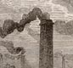
Britain was the first country in the world to have lots of factories. Factory machines made all kinds of things. Machines did jobs, such as spinning, previously been done by families at home.
Factories were noisy. People had to shout above the rattle and hiss of machinery. They breathed air full of dust, oil and soot. Iron and steel works got so hot that workers dripped with sweat. Flames and sparks lit up the sky darkened by smoke from factory chimneys.
- What were cotton mills?
Cotton mills were factories where cotton was spun into thread. In woollen mills, wool was spun in a similar way. Weaving machines turned the thread into textiles, such as cloth and carpets. In Victorian Britain, the cotton and wool industries employed thousands of workers, mostly in the north of England.
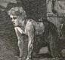
Mill workers lived in small houses close to the factories.
- Why was factory work dangerous?
Factory owners employed children because they were cheap, did not complain, had nimble fingers, and could crawl about under machines.
Small girls worked in mills as 'piecers'. They mended broken threads. 'Scavengers' crawled beneath clattering machines to pick up scraps of cotton. They risked getting caught in the machinery, losing hair or arms. Yet most mill-owners thought factory work was easy. At first, there were no laws to protect working children.
- New laws to protect children
People called reformers, such as Lord Shaftesbury (1801-1885), argued in Parliament for laws to stop child-work. Inspectors, called Commissioners, went into factories and mines. They talked to working children to find out the facts. These are three of the new laws passed by Parliament.
1841 Mines Act - No child under the age of 10 to work underground in a coal mine.
1847 Ten Hour Act - No child to work more than 10 hours in a day.
1874 Factory Act - No child under the age of 10 to be employed in a factory.

Task 1:
Imagine you are a grandparent and were a child in Victorian times. Your grandchildren have some questions they want to ask about your Childhood memories.
Here are some of the questions. Fill in the answers.
1. How many brothers and sisters did you have?
__________________________________________________________
2. Was your family rich or not very well off?
__________________________________________________________
3. Were there any rules you had to follow?
__________________________________________________________
4. Did you have any toys?

5. What games did you play out in the street?

6. Did you ever go on holiday or for a day out?
_________________________________________________________________________
_________________________________________________________________________
_________________________________________________________________________

What do you think?
Make a list of things that were different in Victorian times to your own childhood.
__________________________________________________________________________________________________________________________________________________________________________________________________________________________________________________________________________________________________________________________________________________________________________________
Make a list of things that are similar in Victorian times to your own childhood.
__________________________________________________________________________________________________________________________________________________________________________________________________________________________________________________________________________________________________________________________________________________________________________________
Task 2: Children at work.
You have been asked by a museum to help design a display about working children. First, choose one of the following places where the children were at work.
In farming, in a coal mine or in a textile factory.
Draw the scene which will be the background for the display. Write notes on the drawing to help the designer, such as ‘raining’, ‘dark’, etc.

Task 3: Imagine you are a child living in the Victorian times.
1. Who are you? (name) ___________________________
2. How old are you? ___________________________
3. Where do you live in England? ___________________________
4. Who do you live with? ______________________________
5. Describe your home? ________________________________________________________________________________________________________________________________________________________________________________________________________________________________________________________________________________________________________
6. You don’t go to school anymore; you have to go to work as one of the following;
1. A scullery maid in a rich person’s house.
2. A ‘putter’ or a ‘trapper’ in a coal mine.
3. A ‘piecer’ in a cotton mill.
4. Or a different job of your choice. (Check with your teacher to see if this is suitable).
I am a ________________________________________.
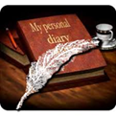
7. Write a diary describing a week in your life. Remember you work hard, probably don’t eat much, maybe you are ill, your family life might be hard etc. There may also be some enjoyable moments. Maybe the fair or circus has come to town or you are going out on a day trip. Use your imagination.

An extract from Eliza‘s diary. (A 13 year old girl working at a mill in Manchester.)
Monday 23 May 1842
Am so tired, I can scarcely bear to write at all, and my legs and arms ache so much. Mother took one look at me, when I came through the door this evening and told me to go upstairs to rest. But I wouldn't, not until I'd cleaned away the dirt - the fluff that still clung to me, the oil staining my hands and feet. Afterwards, I must have fallen asleep because I awoke to find someone shaking my shoulder and I was terrified it was morning again. But it was only Mother, waking me for supper. I followed her downstairs but I could hardly get anything down. Those big machines still haunt me. I had to stand behind them and watch the slivers of cotton unreel into the large cans. They're four feet tall – nearly as big as me. My hands were shaking so much at first that I thought I'd drop them. And the endless sweeping and cleaning. And all the time, longing to sit down – even for a minute. And that smell of oil and sweat, and the fluff that gets into the water and even on to your food. But worst is knowing that tomorrow I'll have to go there again.
Monday: ______________________________________________________________________________________________________________________________________________________________________________________________________________________________________________________________________________________________________________________________________________________________________________________________________________________________________________________________________________________________________________________________________
Tuesday: ______________________________________________________________________________________________________________________________________________________________________________________________________________________________________________________________________________________________________________________________________________________________________________________________________________________________________________________________________________________________________________________________________
Wednesday :
______________________________________________________________________________________________________________________________________________________________________________________________________________________________________________________________________________________________________________________________________________________________________________________________________________________________________________________________________________________________________________________________________
Thursday: __________________________________________________________________________________________________________________________________________________________________________________________________________________________________________________________________________________________________________________________________________________________________________________
Friday: ______________________________________________________________________________________________________________________________________________________________________________________________________________________________________________________________________________________________________________________________________________________________________________________________________________________________________________________________________________________________________________________________________
Saturday: ______________________________________________________________________________________________________________________________________________________________________________________________________________________________________________________________________________________________________________________________________________________________________________________________________________________________________________________________________________________________________________________________________
Sunday: ______________________________________________________________________________________________________________________________________________________________________________________________________________________________________________________________________________________________________________________________________________________________________________________________________________________________________________________________________________________________________________________________________

