Heroes and Legends
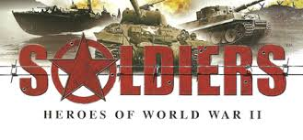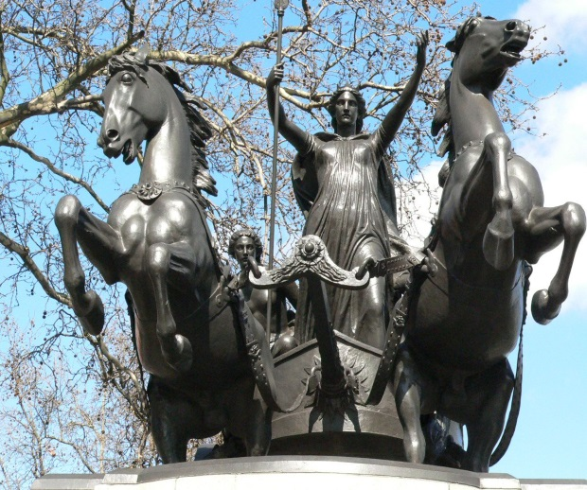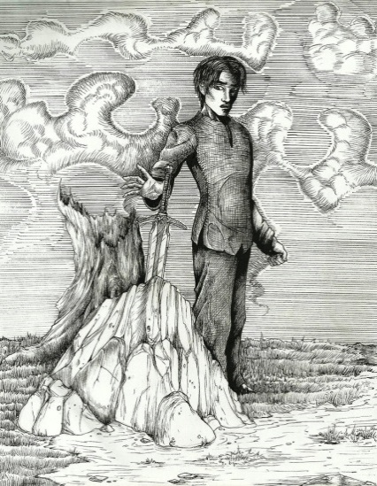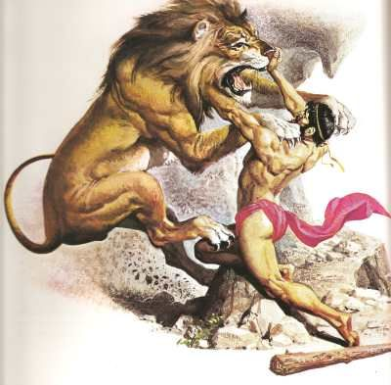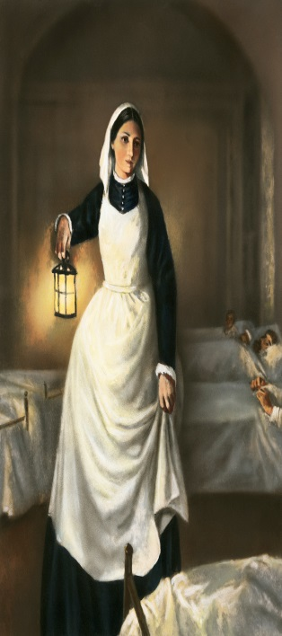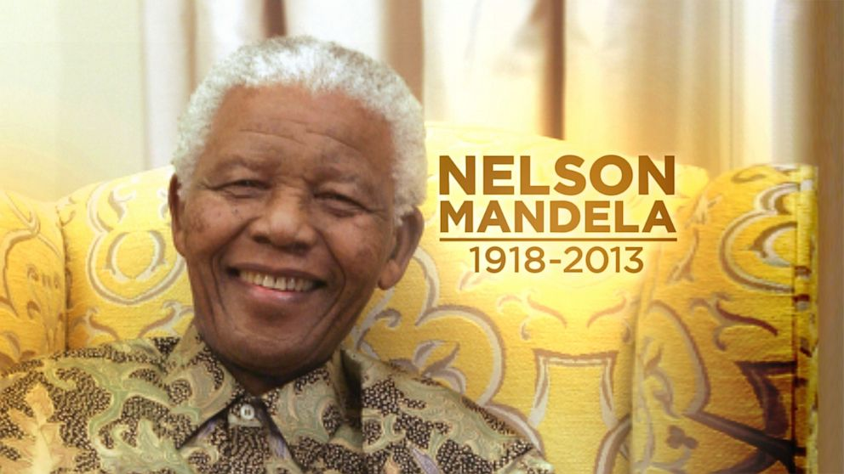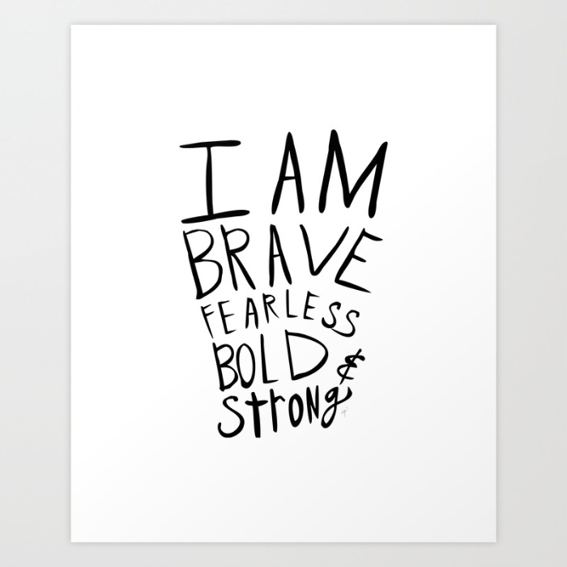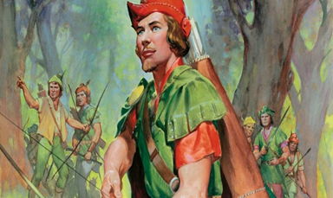
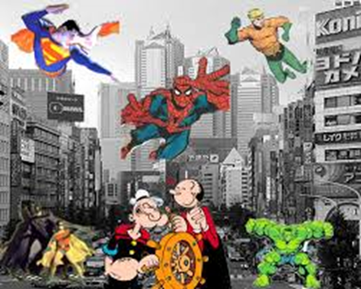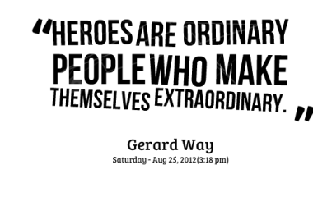

Fill in words you think describe a hero.
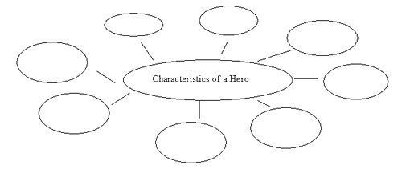

Who is your hero?
___________________________________________
Why is this person your hero?
__________________________________________________________________________________________________________________________________________________________________________________________________________________________________________________________________________________________________________________________________________________________________________________________________________________________________________________________________________________________________________________________________________________________________________________________________________________________________________________________________________________________________________________________________________________________________________________________________________________________________________________________________________________________

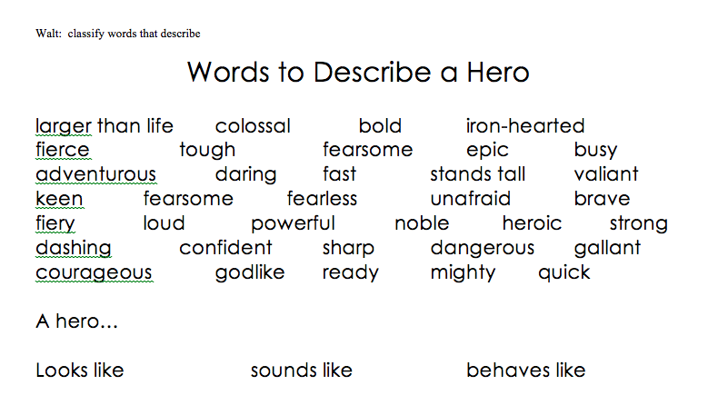

Describe your hero.
1. What does he/she look like?
____________________________________________________________________________________________________________________________________________________________________________________________________________________________________________________________________________________________
2. What does he/ she sound like?
____________________________________________________________________________________________________________________________________________________________________________________________________________________________________________________________________________________________
3. What does he /she behave like?
_____________________________________________________________________________________________________________________________________________________________________________________________________________________________________________________________________________________________

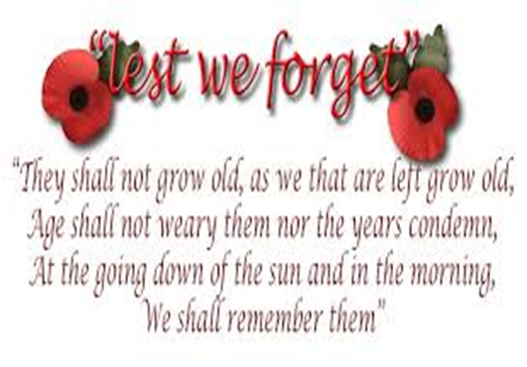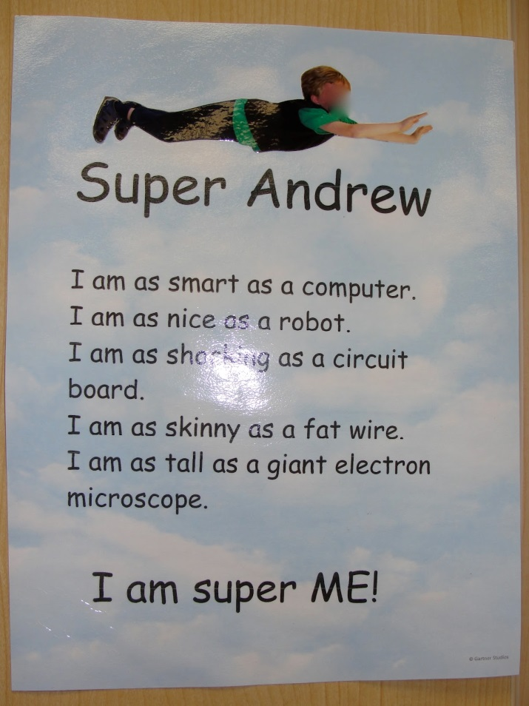""Heroes""
I, I will be king
And you, you will be queen
Though nothing will drive them away "Save The Hero"
We can beat them, just for one day
We can be Heroes, just for one day
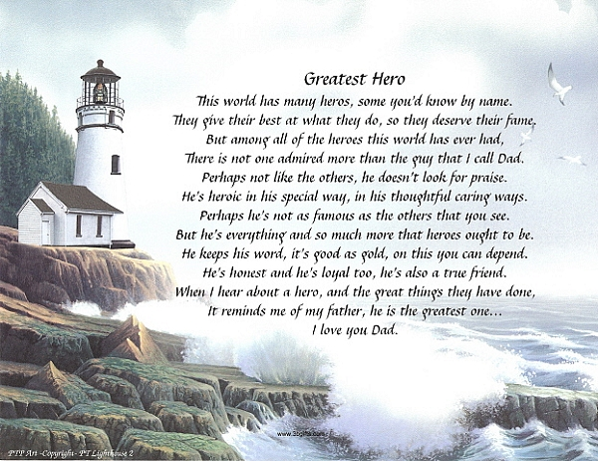
Who's there to save the hero
When she's left all alone
And she's crying out for help.
Who's there to save the hero
Who's there to save the girl...
After she saves the world
After she saves the world.

Find a song or a poem about heroes or legends (or write your own).
Write down the words of the song/ poem in the space below.

Why did you choose this poem/song?
_____________________________________________________________________________________________________________________________________________________________________________________________________________________________________________________________________________________________
Poster presentation:

Aims: to produce a poster, giving detailed information about a legendary or mythological character and to present the information on the poster to the rest of the class.

You can work alone or in groups of 2-3.
You will need to:

- Research information about your chosen character.
- Research information about what happened to the character.
- Collect and print photos or pictures about your character.
- Write an introduction and conclusion for the presentation.

Research work will be done as homework. You will be given some time in the lessons to work individually or together as a group on the poster and to prepare and practise the presentation. You will prepare speech cards for your part of the presentation.

The poster must include the following information:

a. A title.

b. The history / origins of your character.
c. Photographs or pictures of character.

You may add any decorations you wish to your poster. Use your imagination and fantasy!

The presentation must include the following information:
- Introduction: Who is he/she? Why did you choose this character?
- Information from the poster. What? How? When? Who?
- Conclusion: What do you think about the character? What did you think about the assignment?

You may use props, music, songs, sketches or poems to help you present your legend or myth.
