Following Severo Ochoa through the World
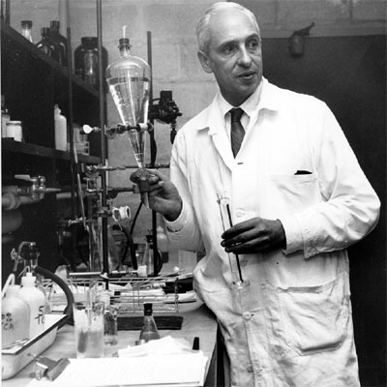
This is an activity for 12 and 13 year old students. The activity is designed for two sessions of 55 minutes each.
Concepts under development:
- Cartesian Coordinates.
- Maps & Geography.
- Applying Maths to solve everyday problems.
- Basic Geometry.
- Skills using Information and Communications Technologies.

Before beginning the activity a short introduction about GPS, GALILEO and GLONASS is recommended.
Information from Wikipedia about them can be found in:
https://en.wikipedia.org/wiki/Global_Positioning_System
https://en.wikipedia.org/wiki/Galileo_(satellite_navigation)
https://en.wikipedia.org/wiki/GLONASS

It can be emphasised the importance of triangulation to get the coordinates of place.

The first point is to refresh Cartesian Coordinates and compare them with the coordinates in a map. This way, the students will see that they are already familiar with these concepts.

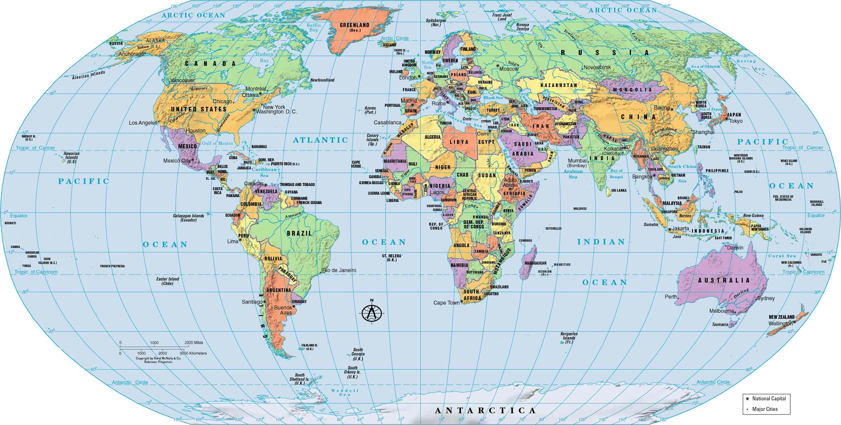

The students are allowed to use devices with internet connections to solve this activity.

- Could you point out the important places in Severo Ochoa’s life?
Give the coordinates of the following places:
He was born in Ḷḷuarca in 1905.
He moved to Málaga when he was 7 and he studied “High School” there.
He received his Degree in Medicine in Madrid (Complutense University).
He passed away in Madrid in 1993.
He was buried in Ḷḷuarca.

- Severo lived part of his life abroad. After graduating he continued studying in different places of Europe:
Glasgow (Scotland)
Berlin (Germany)
London (England)
Heidelberg (Germany)

- He worked as a Professor at the Faculty of Medicine in Madrid but he moved abroad to continue researching because of the Spanish Civil War in 1936.
How long was the Spanish Civil War? Where did Severo Ochoa go? It is the country with coordinates…

- World War II made him emigrate again, first to a country with coordinates… where he continued researching. Finally he moved to a city in the USA with coordinates… (New York) where he discovered the enzyme related to the synthesis of RNA which made him win the Nobel Prize.

- Where are the Nobel Prize awarded? In a city with coordinates

- Severo Ochoa got another citizenship in 1956. What was that country? Coordinates…

- Severo Ochoa was born in 1905 and he died in 1993. Taking into account that he migrated from Spain in 1936 and he did not come back to stay for good until 1975. What percentage of his life did he live abroad?

- Severo Ochoa was born in Ḷḷuarca in 1905 and he moved to Málaga with his mother due to his father’s death. They moved when he was 7 years old and he finished his Degree in Medicine 17 years later. When did he finish his Degree?

- He married Carmen García Covián 4 years before the beginning of the Spanish Civil War. 23 years after their marriage he was awarded with the Nobel Prize in the area of Physiology and Medicine. What year was he awarded the Nobel Prize?

- He spent his last 18 years in Spain. He passed away in Madrid when he was 88. When did he come back to Spain from the USA if he was born in 1905?

