Word list Victorian England (Industrial revolution).

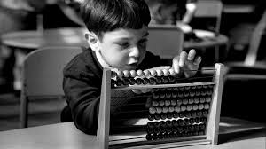
Abacus .This was a wooden frame with beads on it. It was used to help children with counting sums.
Agricultural gang. This was a group of workers in the countryside, doing jobs like weeding, sowing seeds, and harvesting crops. Often these gangs would include young children.
Barrel organ. A musical instrument which was taken round the streets. It played music when the handle was turned. Often the owners of barrel organs had tame monkeys.
Band of Hope. Temperance organization which tried to stop people, especially children, from drinking alcohol.
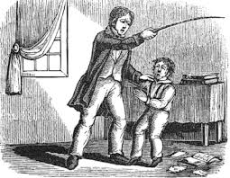
Boarding school. A school where children live during term time, coming home for the holidays.
Boys' Brigade. Youth organization started in 1883 in Glasgow.
British Empire. Countries ruled by Britain; later became the Commonwealth.
Cane. Thin stick used by teachers to beat children who misbehaved.
Census. This is the record of people living at a certain time. It records how many people there are, where people live, their age and what they do.
coal mine. A place where coal is dug from under the ground.
Coal. Remains of prehistoric trees, burned in fires. In Victorian times, coal heated homes and provided steam power for machines, trains and ships.
Contraception. Another term for birth control, or stopping unwanted pregnancies.
Cotton. Comes from a plant. It is spun into thread then woven to make cloth.

E to G
dame school. A school run in her home by an elderly woman, known as a dame, where children were taught basic reading and writing.
Diphtheria. Infectious throat disease that killed many children.
Emigrated. To emigrate is to leave your own country to go and live in another.
Empress. The female ruler of an empire, or the wife of an emperor.
Factory. Building with machines for producing goods in large numbers.
Factory commission. A group of men who travelled around Britain to investigate the working conditions of children in both factories and mines.
Fire grate. The metal part of a fire and fireplace. 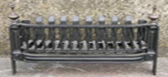
Globe. A map of the world drawn on a sphere, useful in geography lessons. 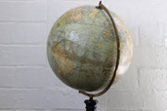
Governess. A woman who taught rich girls and young boys in their homes, as a paid, live-in servant.
Grammar school. Boys' schools, started in the Middle Ages as an alternative to Church schools and giving free education to some boys.

H to L
Hokey-pokey man. Icecream-seller, originally usually Italian.
Hopscotch. A hopping game played in the street or playground.
Hurdy-gurdy. A mechanical violin, played by a street musician.
Industrial revolution. The era of rapid and great change in industry and manufacturing with the growth of factories, beginning in the late 1700s.
Ink well. A small pot for ink, used by school children.
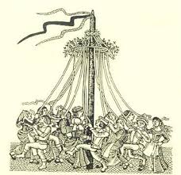
Logbook. Diary or record book of events.

M to O
Magic lantern. A slide projector for showing pictures on a screen.
Maypole. Tall pole with long ribbons, for dancing around on May Day.
Moral. A lesson often in a story, about right and wrong.
Music hall. Popular Victorian theatre with variety acts such as singers, dancers and comedians.
Nanny. servant who cared for rich young children in their nursery at home.
Nursery. A room or several rooms where rich children would play and sleep.
Orphan. Child with no living parents.

P to S
Parliament. Law-making body made up of elected Members of Parliament (MPs) and non-elected Lords.
Piecer. A child who worked in a mill joining pieces of thread together.
Population. The number of people in a country or city.
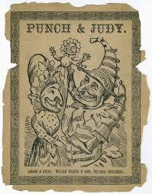
public schools. Fee-charging schools for children from richer families.
Punch and Judy show. A hand-puppet show which features Mr Punch and his wife Judy. Common at the seaside in Victorian times.
Ragged school. A school for poor children in the early 19th century.
Reformer. Person who seeks change for the better, to help others.
Reign. The length of time a king or queen rules.
school board. A group of people who were responsible for the running of their local school after 1870.
Scullery. Small room with a sink, for washing up.
Shaft. Deep vertical hole leading down to the tunnels and underground workings of a coal mine.
Slates. These were pieces of slate (like a flat stone), sometimes set inside a wooden frame, used for writing - with a special slate pencil. At the end of the lesson the slates were wiped clean with an old cloth.
Smallpox. Disease causing fever and, in those who did not die from it, leaving 'pockmarks' on the skin.
Steam engine. Engine driven by steam from heated water, used to drive machinery. 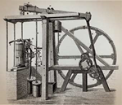
Slum. An area of bad housing, with poor hygiene and sanitation.
Sunday School. School to teach Christianity: the National Sunday School Union was founded in 1803.

T to Z
Wages. Workers' pay.
Wool. Comes from sheep. It is spun into thread then woven to make cloth.
Workhouse. Place where people without means of support (usually the very poor, young and elderly) were sent to live; they got a food and a bed in return for work. Most Victorian towns had a workhouse.
